[Request Maintenance System]

Database Design Document

Submitted By:
_________
__________
Submitted To:
__________

Department of Software Engineering
University of Mianwali
Mianwali, Pakistan
Submission Date : _________

Project Overview:
The Maintenance Request System is a web-based application developed to manage and track maintenance issues efficiently within an organization, building, or institution. The system allows users to submit maintenance requests, assign tasks to staff members, monitor progress, and generate reports.
The system provides a user-friendly graphical interface (GUI) that ensures real-time synchronization between the front end and the MySQL database, enabling accurate and secure handling of maintenance-related data.
Modules Implemented:
The Maintenance Request System consists of the following functional modules:
- Location Management
- Staff Management
- Request Management
- Report Management
- IssueType Management
Each module allows full CRUD (Create, Read, Update, Delete) operations with search functionality.
Technology Stack:
- Frontend / GUI: HTML, CSS
- Backend / Server: PHP 8+
- Database: MySQL
- Development Environment: XAMPP (Apache & MySQL)

- Maintenance Staff Table
Column Name | Type | Description
StaffID | INT (Auto Increment) | Primary Key
StaffName | VARCHAR(100) | Full name of maintenance staff
ContactNumber | VARCHAR(20) | Staff contact number
Email | VARCHAR(100) | Staff email address
Role | VARCHAR(50) | Job role (Electrician, Plumber, etc.)
Column Name | Type | Description
CustomerID | INT (Auto Increment) | Primary Key
Name | VARCHAR(255) | Customer full name
ContactInfo | VARCHAR(255) | Contact number or email

2. Location Table
Column Name | Type | Description
LocationID | INT (Auto Increment) | Primary Key
BuildingName | VARCHAR(100) | Name of the building
RoomNumber | VARCHAR(10) | Room number
FloorNumber | INT | Floor number
Description | VARCHAR(150) | Additional location details
Column Name | Type | Description

3. Issue Type Table
Column Name | Type | Description
IssueTypeID | INT (Auto Increment) | Primary Key
TypeName | VARCHAR(50) | Type of maintenance issue
Description | VARCHAR(150) | Issue description
Column Name | Type | Description
IssueTypeID | INT (Auto Increment) | Primary Key
TypeName | VARCHAR(50) | Type of maintenance issue
Description | VARCHAR(150) | Issue description

4. Maintenance Request Table
Column Name | Type | Description
RequestID | INT (Auto Increment) | Primary Key
UserID | INT | ID of the user who submitted the request
IssueTypeID | INT | Foreign Key → Issue Type
LocationID | INT | Foreign Key → Location
RequestDescription | VARCHAR(255) | Details of the maintenance issue

5. Request Assignment Table
Column Name | Type | Description
AssignmentID | INT (Auto Increment) | Primary Key
RequestID | INT | Foreign Key → Maintenance Request
StaffID | INT | Foreign Key → Maintenance Staff
AssignedDate | DATE | Date staff was assigned
CompletionDate | DATE | Date request was completed
AssignmentStatus | VARCHAR(50) | Assignment status (Assigned / Completed)

6. Maintenance Logs Table
Column Name | Type | Description
LogID | INT (Auto Increment) | Primary Key
RequestID | INT | Foreign Key → Maintenance Request
StaffID | INT | Related staff member
LogDate | DATETIME | Date and time of activity
LogDetails | VARCHAR(255) | Description of maintenance activity

7. Users Table
Column Name | Type | Description
UserID | INT (Auto Increment) | Primary Key
Username | VARCHAR(100) | System user name
Password | VARCHAR(255) | Encrypted user password
Role | VARCHAR(50) | User role (Admin / User)

7. View: Maintenance Request Details (vw_requestdetails)
Column Name | Type | Description
RequestID | INT | Maintenance request ID
RequestDescription | VARCHAR(255) | Issue description
RequestDate | DATE | Date of request
Status | VARCHAR(50) | Current request status
Requester | VARCHAR(100) | Name of request creator
IssueType | VARCHAR(50) | Issue type name
Location | VARCHAR(111) | Building and room details
AssignedStaff | VARCHAR(100) | Assigned staff name

4. GUI Implementation
Home Dashboard (index.php)
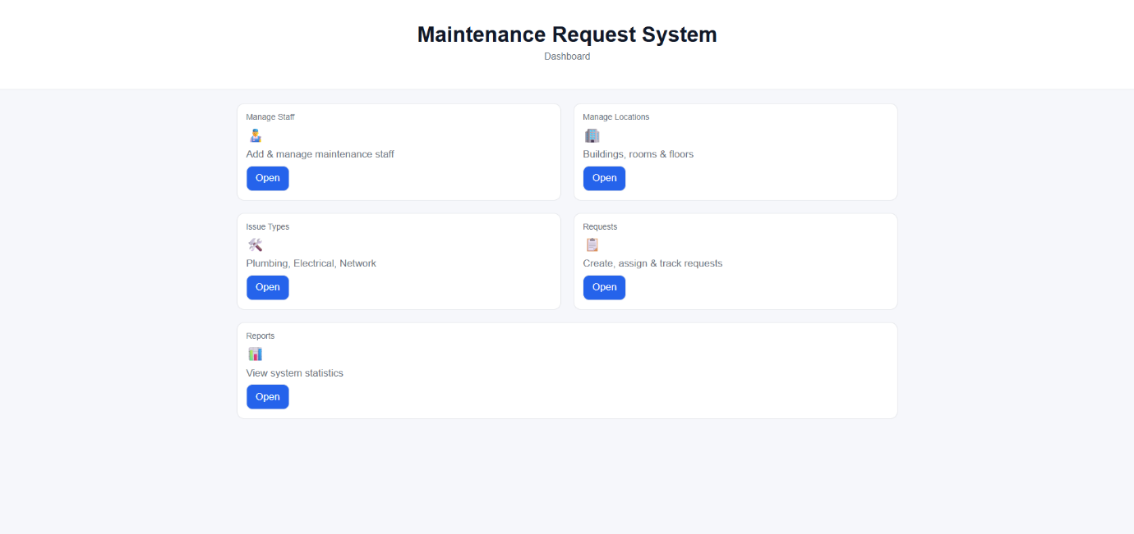
Key Features:
- A centrally aligned dashboard layout with a modern and professional design.
- Large, clearly labeled buttons for each system module to ensure ease of navigation.
- Responsive buttons with smooth hover effects to enhance user interaction.
- Bold welcome heading displayed as:
“Maintenance Request System”
- Supporting instructional text displayed below the heading:
“DashBoard”
Available Modules:
- Mange Staff
- Manage Locations
- Issue Type
- Request
- Reports
The dashboard ensures quick access to all core functionalities of the system while maintaining a user-friendly and visually engaging interface.
Manage Staff:
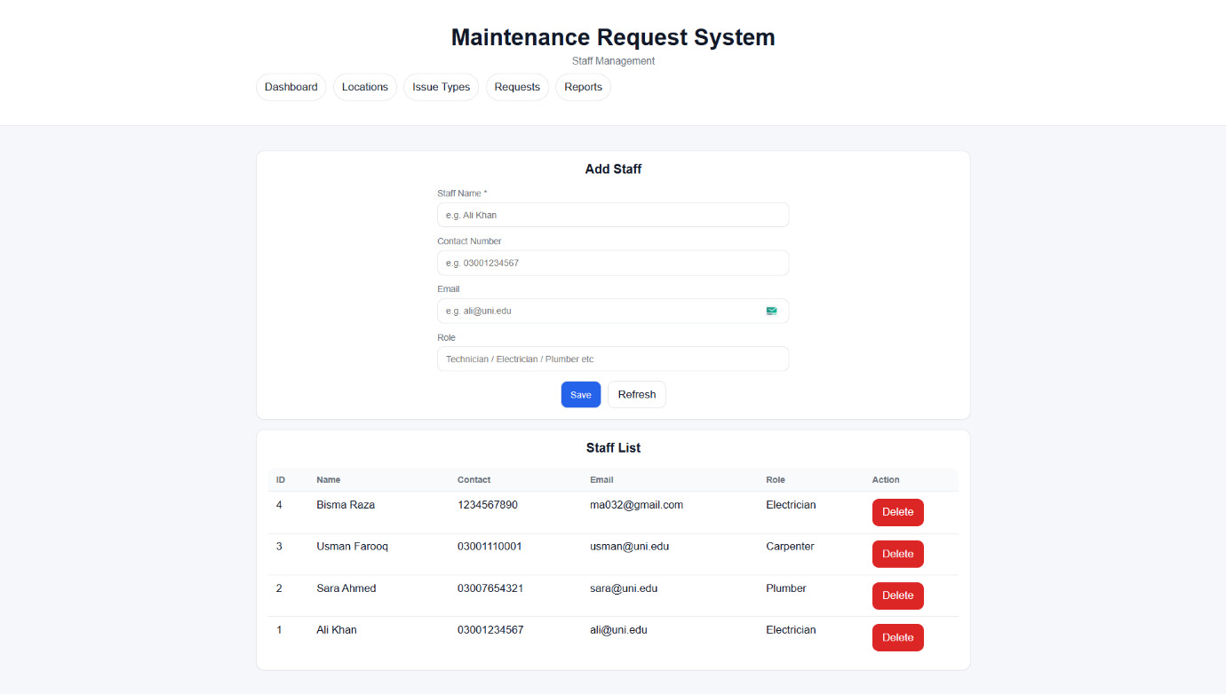

Manage Locations:
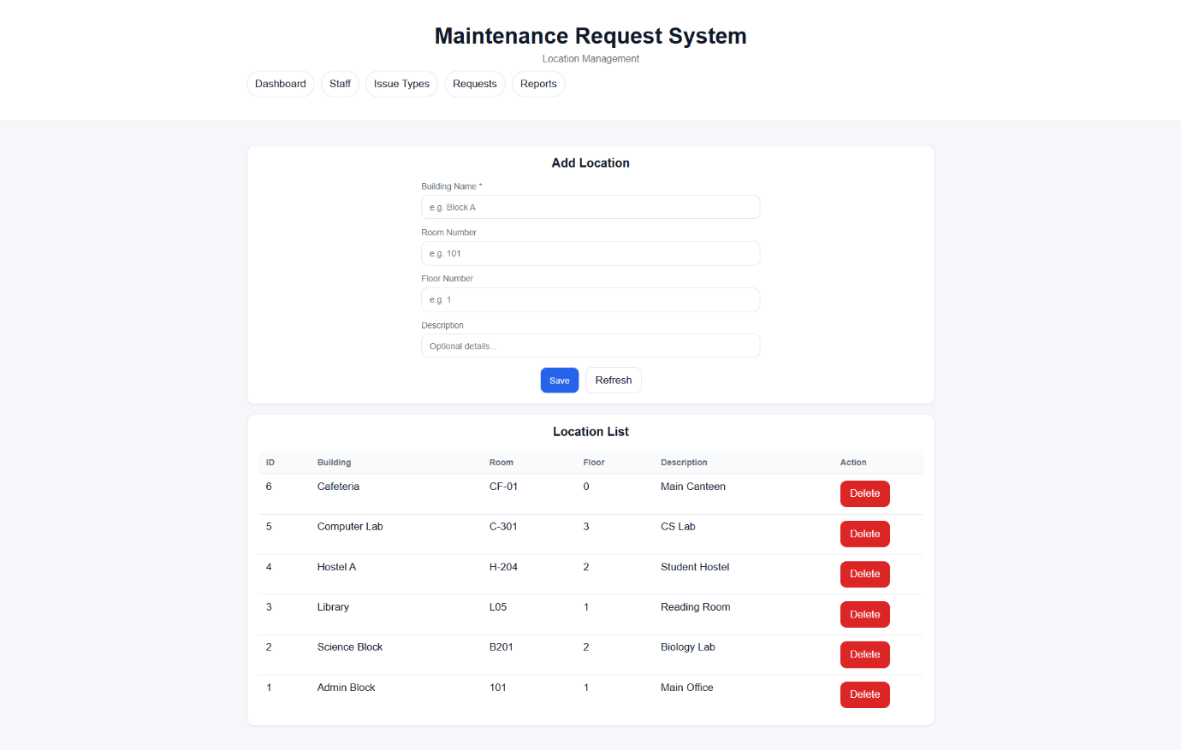
Issue Types:
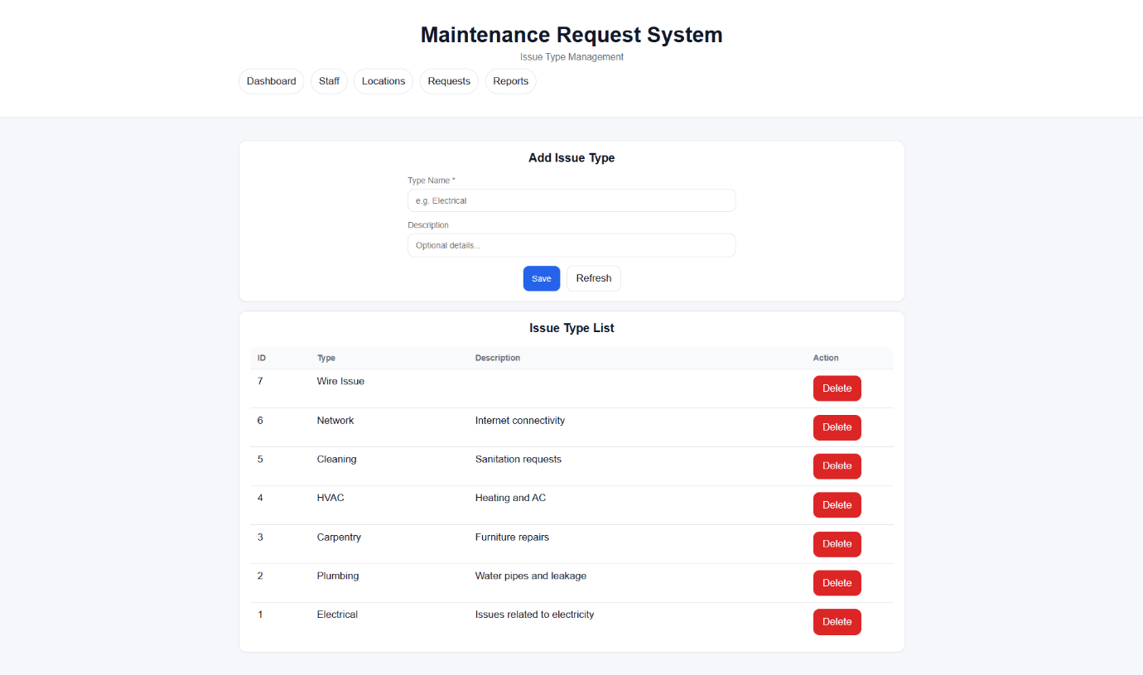
Requests: 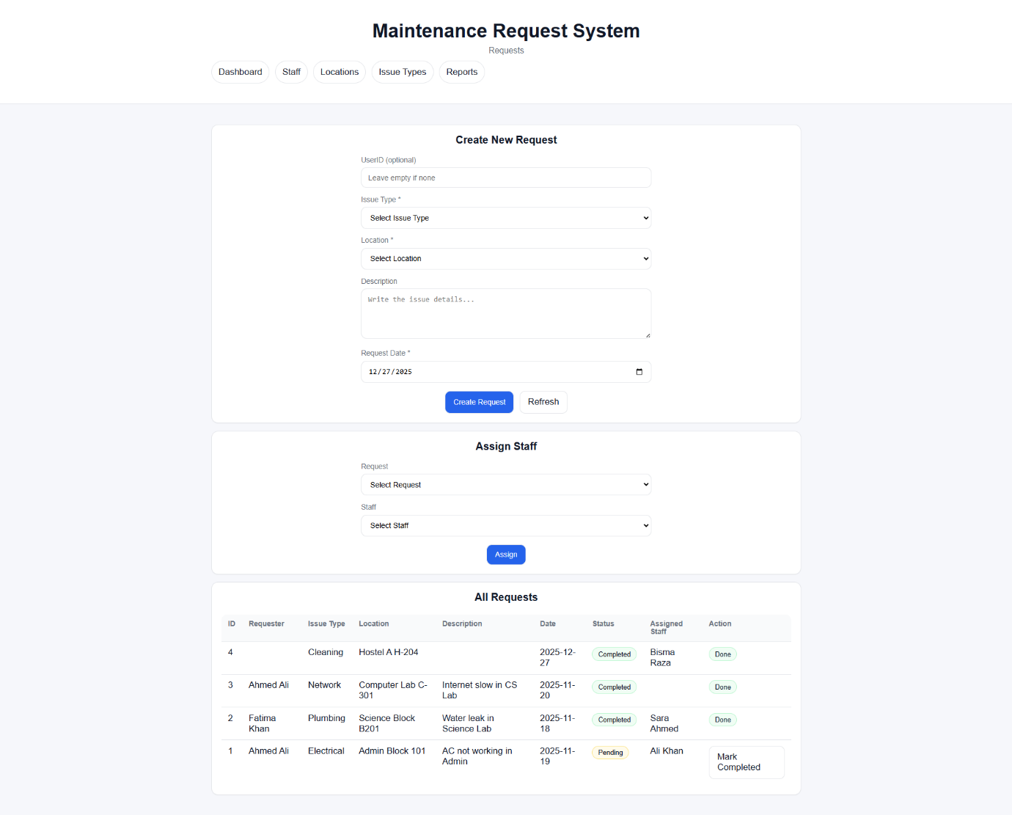
Reports:
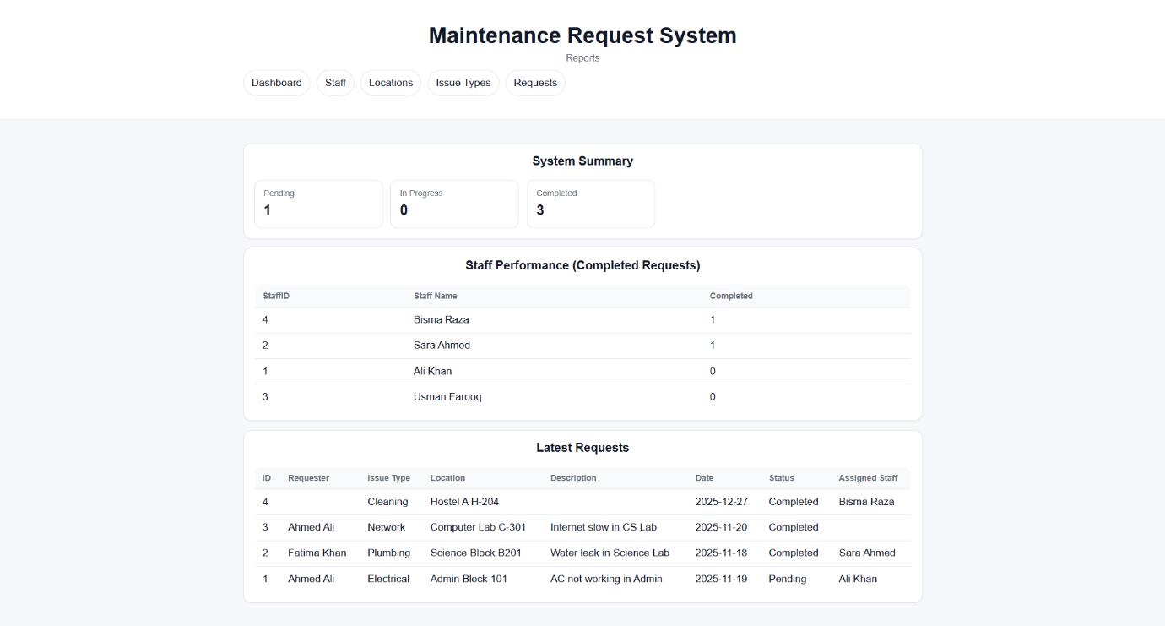

Xamp (Local server)
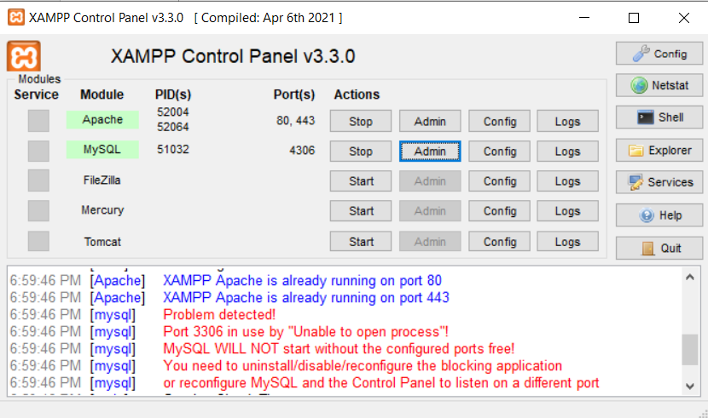
5. Database Connectivity
- File: db.php
- Uses mysqli to connect PHP to MySQL.
- Handles connection errors.
- All CRUD operations call prepared statements for security.
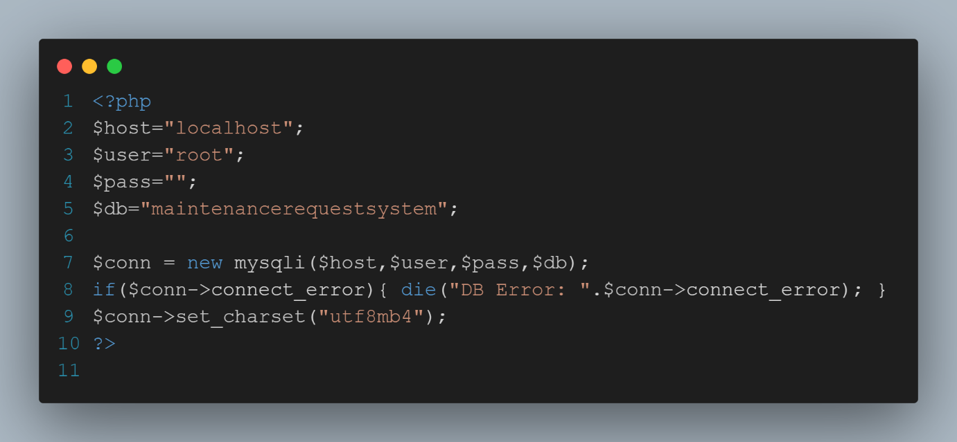

Appendix: AI Prompts Used
The following AI prompts were used during the development of the Maintenance Request System to assist with database design, backend development, frontend GUI design, debugging, and testing:
• Design a MySQL database schema for a Maintenance Request System with staff, location, issue type, request, assignment, and log tables.
• Create SQL scripts with primary keys, foreign keys, constraints, and relationships.
• Insert sample data while maintaining foreign key integrity.
• Resolve foreign key constraint and database connection errors in XAMPP.
• Connect PHP to MySQL securely using mysqli and prepared statements.
• Implement CRUD operations for staff, locations, issue types, and maintenance requests.
• Create functionality to assign staff and update request status.
• Design a responsive and professional dashboard using HTML and CSS.
• Fix CSS layout issues and ensure consistent UI styling.
• Create MySQL views to display request details with names instead of IDs.
• Test frontend forms and verify database updates using phpMyAdmin.
• Debug issues related to localhost paths and “Not Found” errors.
Conclusion
This project successfully developed a GUI-based Maintenance Request System using HTML, CSS, PHP, and MySQL. The system supports all essential CRUD operations, including inserting, displaying, searching, updating, and deleting records through an interactive and user-friendly interface

